**Range Buy Analysis – Sportsgirl Tween Range S/S 19/20**

1. **Colour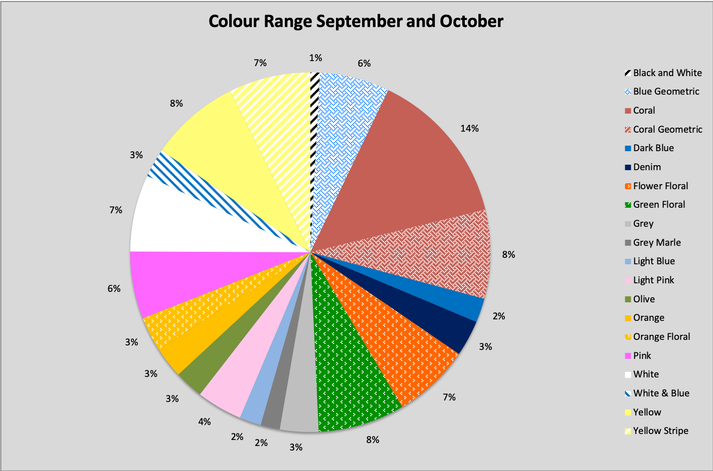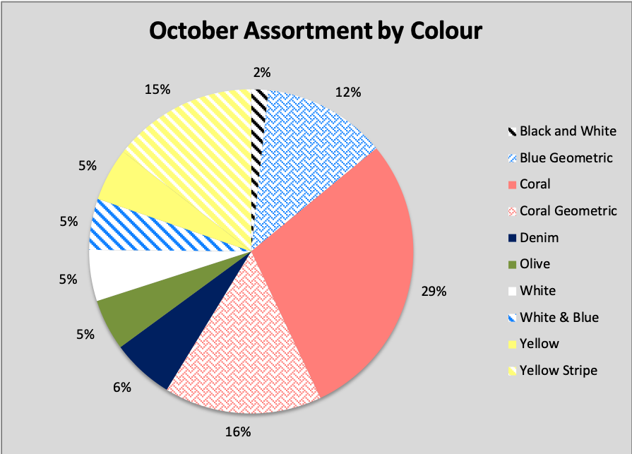 Analysis**

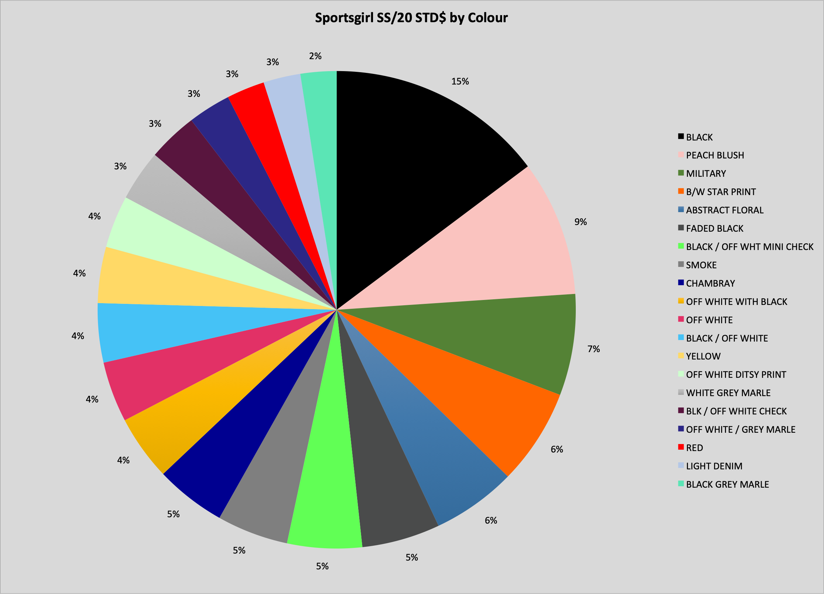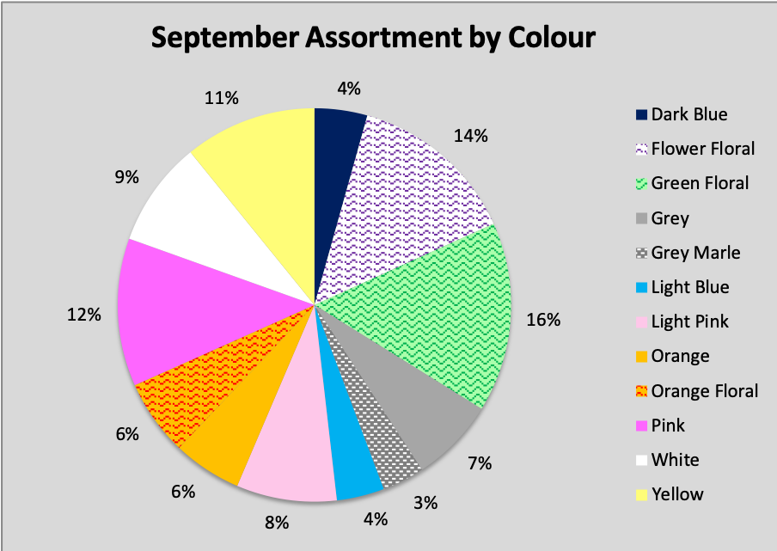

Whilst our Sportsgirl Tween range includes 20 colours as seen on the chart above, due to the nature of tween wear, we chose to use a more 'fun' colour palette as opposed to typical womenswear colours. We are investing more in Fashion Core and Directional colours and prints suitable for the tween market whilst allocating less for basic colours such as black & white, white, grey, grey marle, and white & blue.

Additionally when taking into account our buy plan, colours are a crucial factor that attracts consumers to purchase. There must be a spread of basic, fashion core and direction colours and prints which are appropriately allocated based on previous season’s sales figures.

1. **Allocation by Subclass**

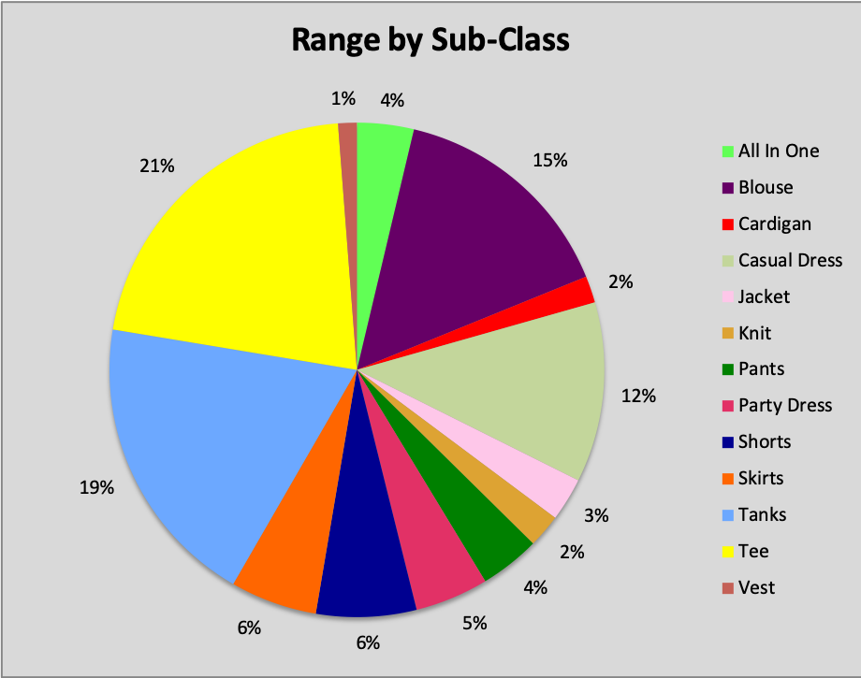

The data shown in the above chart demonstrates that we have distributed 19% of our range for tanks for the season, however, we may have allocated too many blouses (15% of our total range). Only 6% from our total range was allocated for skirts, which may not fulfil the demand from our core consumer.

1. **Allocation According to Climate**

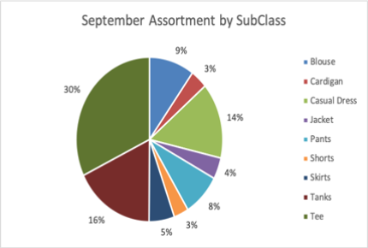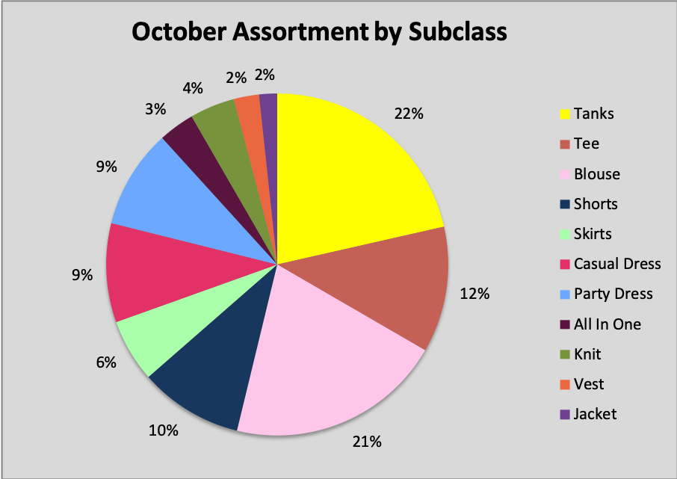

When allocating items for each month, seasonal changes from September and October were considered, with each drop featuring a unique allocation of items based on subclass (see above charts).

In the month of September, due to a milder climate, items including pants and t-shirts are allocated appropriately where as we see the warmer climate of October featuring a greater allocation of items such as shorts and tanks. This data is furthermore supported by the Sportsgirl’s S/S18-19 sales performance indicators, which showed that 4 of 10 of the top selling items for the season were the subclass of shorts.

1. **Pricing of Range**

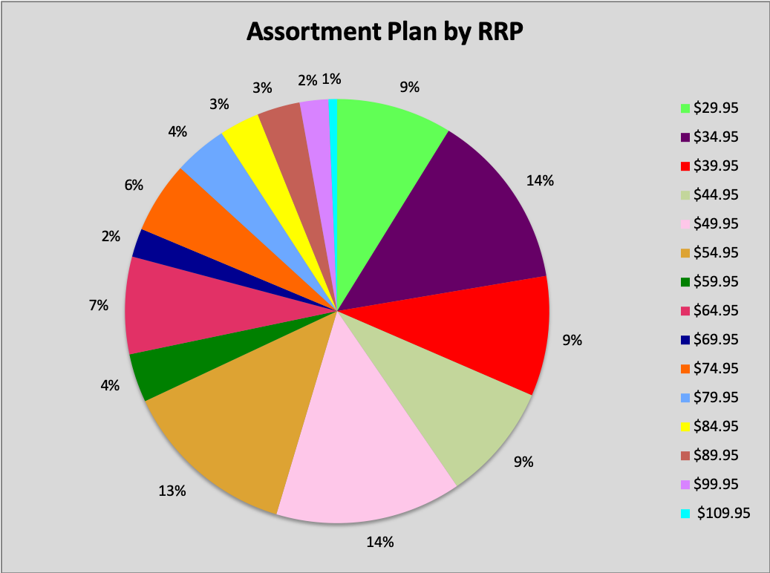

Pricing can attract or detract consumers especially when they see a large range of prices. Whilst pricing can increase depending on the items classification (basic, fashion core and directional), overall there must be an even spread. A range should not have a myriad of price points, if anything they must be calculated as to attract potential consumers. Our range as shown in the above graph, highlights our pricing range and the increments that we have calculated.

Looking at each month’s pricing, we see that our price range has evenly increasing increments, with the exception of outerwear. Data from Sportsgirl S/S18-19 shows a large range of pricing figures which start at just $19.95 and increase in uneven increments to $218.00. Our range is priced more appropriately, with entry starting at just $29.95 and topping out at $109.95. We allocated more quantities for items priced between $34.95 and $54.95, which we determined was our sweet spot, in order to gain more sales as it fulfils customer's expectation of our price when shopping in our store.

**Pricing Among Competitors**

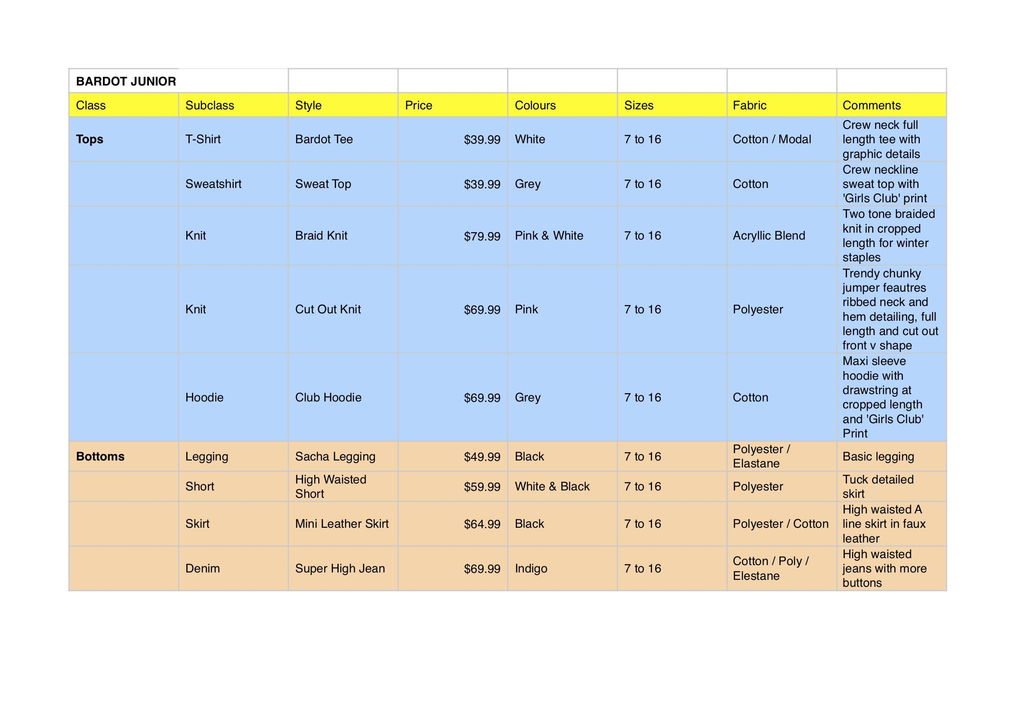

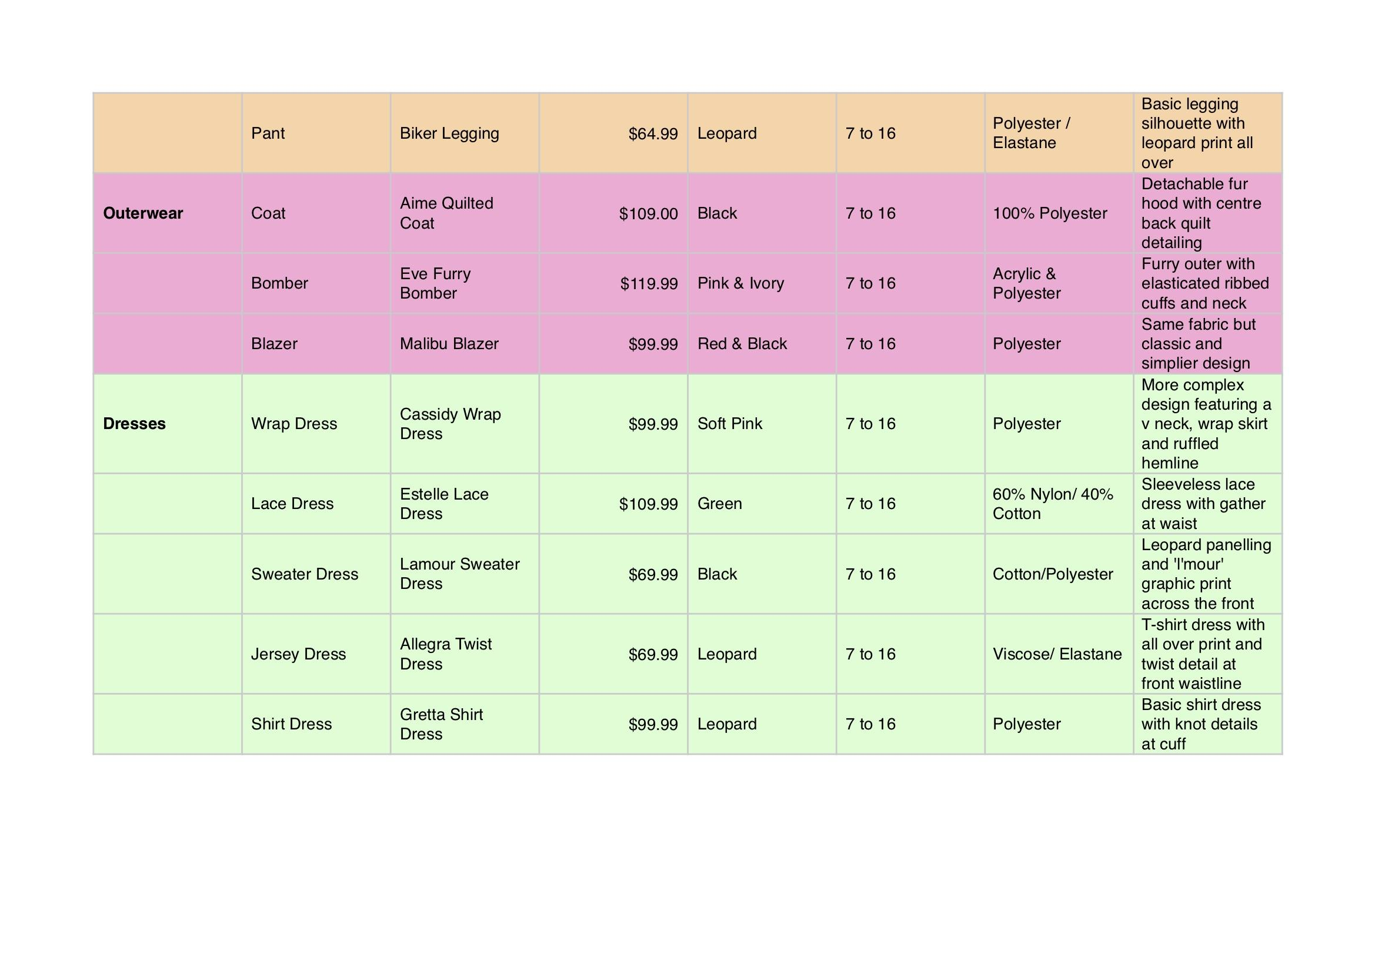

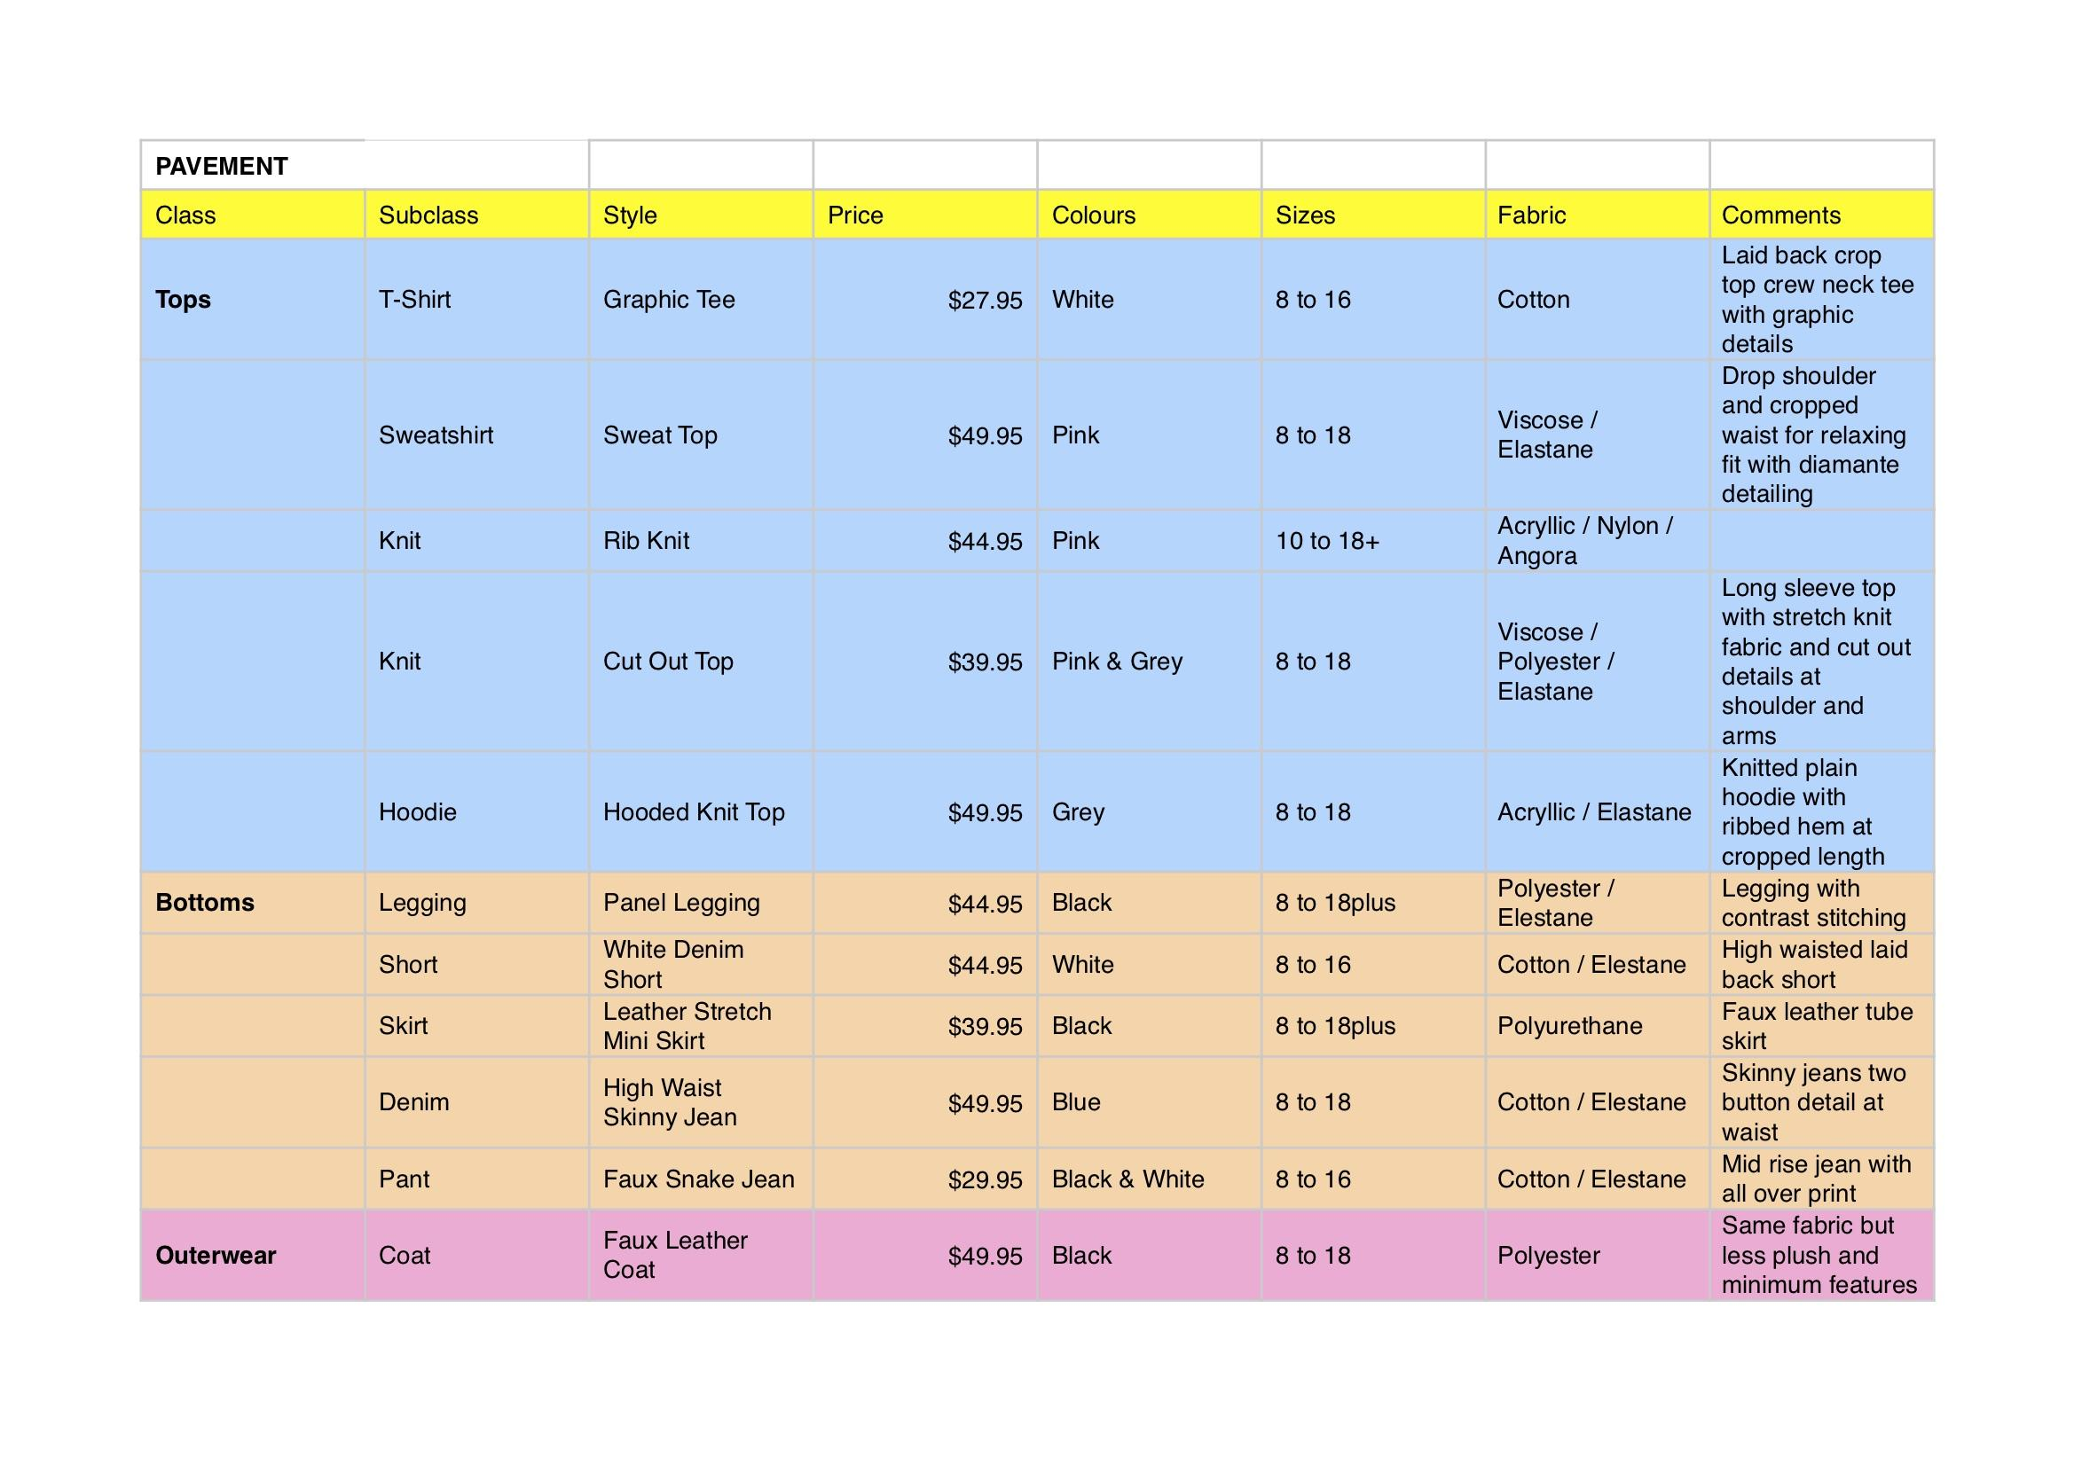

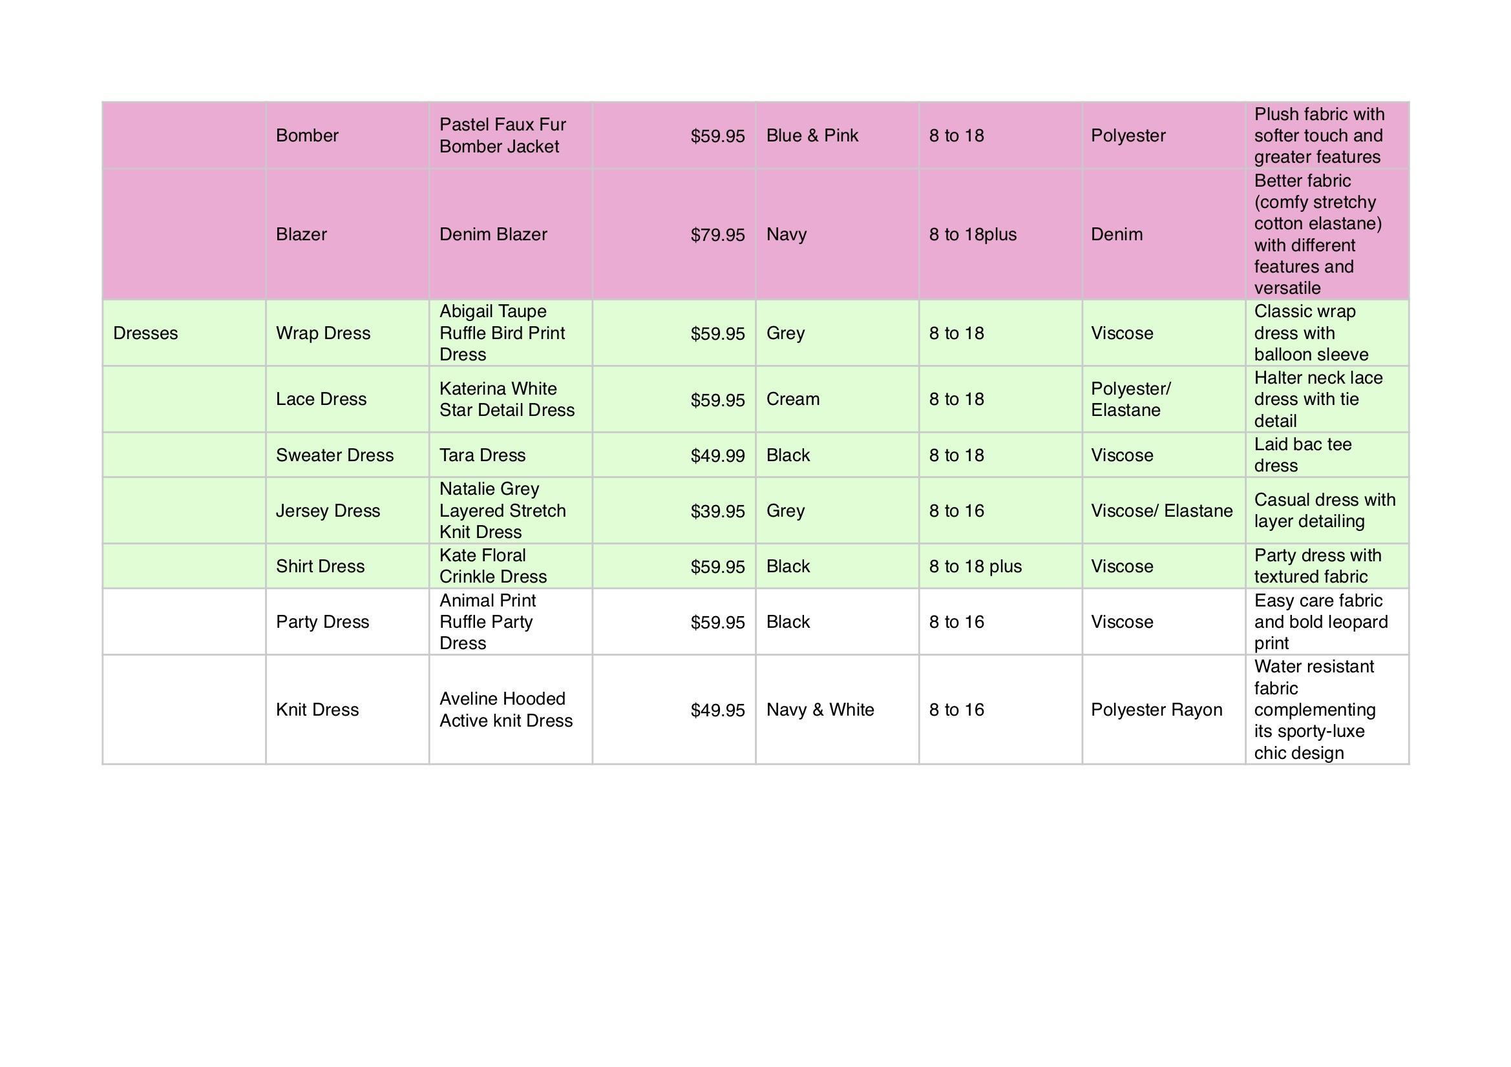

When looking at the market for Australian tween apparel retailers, two brands stood out to us that would be rivals for the Sportsgirl Tween range; Bardot Junior and Pavement.

Analyzing these two brands highlighted varying differences and also similarities between the two; and also with Sportsgirl. On one hand, we identified that Bardot Junior have focused their range very much based on current trends, distancing themselves from what could be considered ‘classic’ or ‘staple’ wardrobe items. As a result of these current on trend items, we see a higher price point with Bardot Junior with some items only being marginally cheaper than their main Bardot womens range.   
  
 Pavement can be considered the “new kid on the block” due to not having an established sister company such as Bardot or Sportsgirl. Despite this, they aim to penetrate the Australian tweens market by undercutting the competition. Affordability is highlighted in our price point analysis with Pavement items sitting 10%-50% cheaper than Bardot Junior in some categories such as their outerwear; Bardot Junior’s Quilted Coat retails for $109.00 compared to Pavement’s Faux Leather Coat, retailing for $49.95. Despite this large price gap, Pavement does not offer such a strong on-trend based range, instead focusing on more basic or classic style garments that can be a part of any staple wardrobe.   
  
 When looking at colour ranges, both Bardot Junior and Pavement have a fairly similar aesthetic with extensive use of neutral colours such as black, navy, white and grey. We found more differentiating trims and details in the products especially when viewing Bardot Junior’s range.   
  
 When positioning Sportsgirl’s tween range, there were a number of competitive pricing strategies we could implement. Rather than price skimming or price penetration, Sportsgirl’s new tween range would sit in between both Pavement and Bardot Junior, thus creating a competitive pricing strategy than seeks to target consumers of both brands. Our tween range aims to fill the gap in design and aesthetic between both brands, whilst it is not as on-trend or directional as Bardot Junior, the designs are more detailed and fashion core than Pavement products of the same category.

**Errors and Imbalances**

1. **Colour Imbalance**

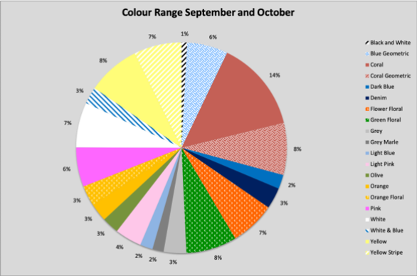  


As previously mentioned, and as seen on the chart above, our range has invested more into bright and bolder colours that are appropriate for the tween market. As a result, there are fewer basic colours such as black & white, white, grey, grey marle, and white & blue.

Sportsgirl’s previous year sales figures indicated that 52 colours were used and applied to their range, whilst that may appear to be a large number, this range included 140 items. Comparatively, the Sportsgirl tween range for September and October features 20 colours and 52 individual items.

When analysing our range and the colour range across both drops as highlighted in the above chart, we notice that there is an imbalance of colours, too many are used, and neutrals are negated. We recommend that the Sportsgirl tween range should focus more on these colours rather than louder and on-trend colour palette positioning itself between Bardot Junior and Pavement. Additionally, when taking into account our buy plan, colours are a crucial factor that attracts consumers to purchase. When taking into account Sportsgirl’s last year sales, black sold at 15%, followed by faded black at 5%, smoke which is a dark grey at 5%, chambray at 5% and off white at 4%. In total this shows 34% of colour from last year was a neutral. Our range should have reflected more of these neutral colours which are proven top sellers.

There must be a spread of basic, fashion core and directional colours and prints, which are appropriately allocated based on previous sales figures. An A-store may have allocation for a directional item as opposed to a C store, colours, especially neutrals would be positively received at any A, B or C store; in turn we should understand the imbalance of colour between on-trend or seasonal and non-seasonal, classic neutrals.

1. **Subclass Allocation**

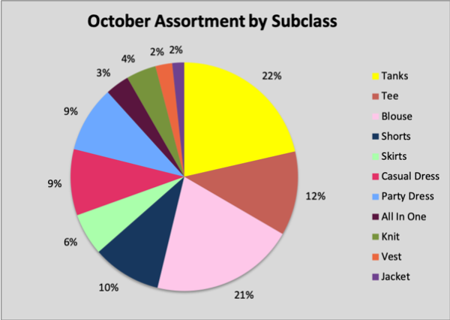

Looking deeper into our range, a glaring omission was found with the balance of our bottoms classification, the October range offered no pants.   
  
 Despite a warmer season approaching, the bottoms offered in October only feature two directional skirts and two basic shorts; all of which were featured best sellers in last year’s data. Even with warmer weather, consumers may still wish to purchase these items and thus we recommend that pants should be offered in October, however in reduced quantities.

Furthermore, looking at our subclasses, another error we identified in October was the allocation of 15% towards Blouses that could be seen as an over allocation.

Despite the warmer climate and summer approaching, we have increased our allocation of blouses and negated the notion of increasing quantities of tees, which sits at 12%. This is an error that would need to be rectified in our range buy by allocating more Tees to properly represent the changing temperatures and to prepare for consumer demand of summer apparel.

1. **Carry-over Stock**

Carry-over stock was not implemented in our range. Despite seeming like quite a large amount, the budgetary requirement of $125,000 is in fact a low budget, and as such, styles could be carried over between the two months.

Currently we have only one style, the Bianca Tank, which is carried over between both months, in varied colours. It may be more beneficial for our range to have more items that are carried over between the two months, especially basics items and featuring a neutral colour palette. Not only would this decrease our budgetary cost, it would free up more space for fashion core and directional items. With a lack of pants in our bottoms category for October, we recommend that the Anais Legging could be carried over into October in a different colour, thus giving consumers a pant option.   
  
 **4. Carry-over Colouring**

Regarding colour, we have two shades of yellow in September and October. When negotiating with a supplier, the two shades could increase manufacturing costs and also constrain our budgetary allowance. If there were to be one shade of yellow, our costs would decrease. A single shade of yellow could be carried over both months, with quantities decreasing in the next month, thus freeing up quantities of other items.   
  
 Having a similar colour palette between September and October would create a more cohesive in-store experience with our range for consumers, as opposed to our current ranges which appear very separate. It could be argued that with such bold colours and patterns in each month’s drop, consumers may be confused when looking at the range as an entirety, thus negatively affecting sales.

**5. Sweet Spot Pricing**

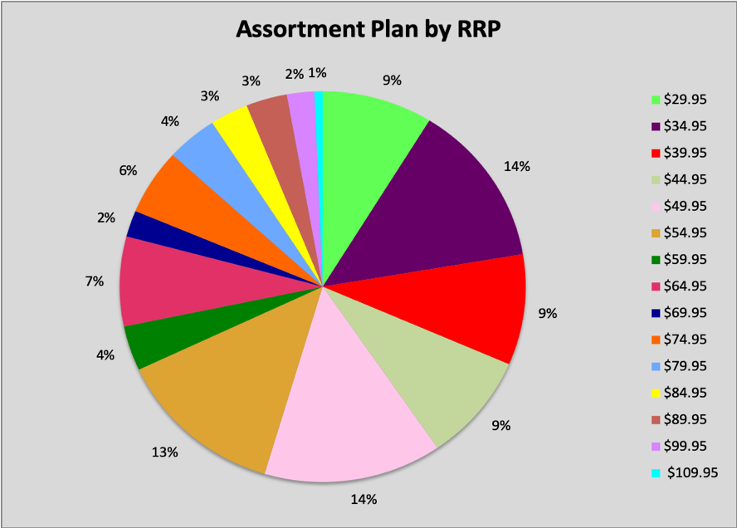  
  
 Previously we have mentioned our sweet spot ranging between $34.95-49.95, we believe this to be too low and almost bordering on Pavement’s current sweet spot.

Initially when justifying our price range, we aimed to set our prices between competitors Pavement and Bardot Junior, in order to differentiate our range. When revising this pricing strategy, we noticed our error of pricing, it was too low. A higher sweet spot would be required in order to truly place ourselves within the market which also reflects on our garments that are not as directional as Bardot Junior, but more Fashion Core compared to Pavement.

Our range’s new pricing sweet spot would range between $49.95 and $64.95; this would truly position Sportsgirl’s tween range between both competitors in terms of product offerings and price points; thus attracting interest of both competitors’ consumers.

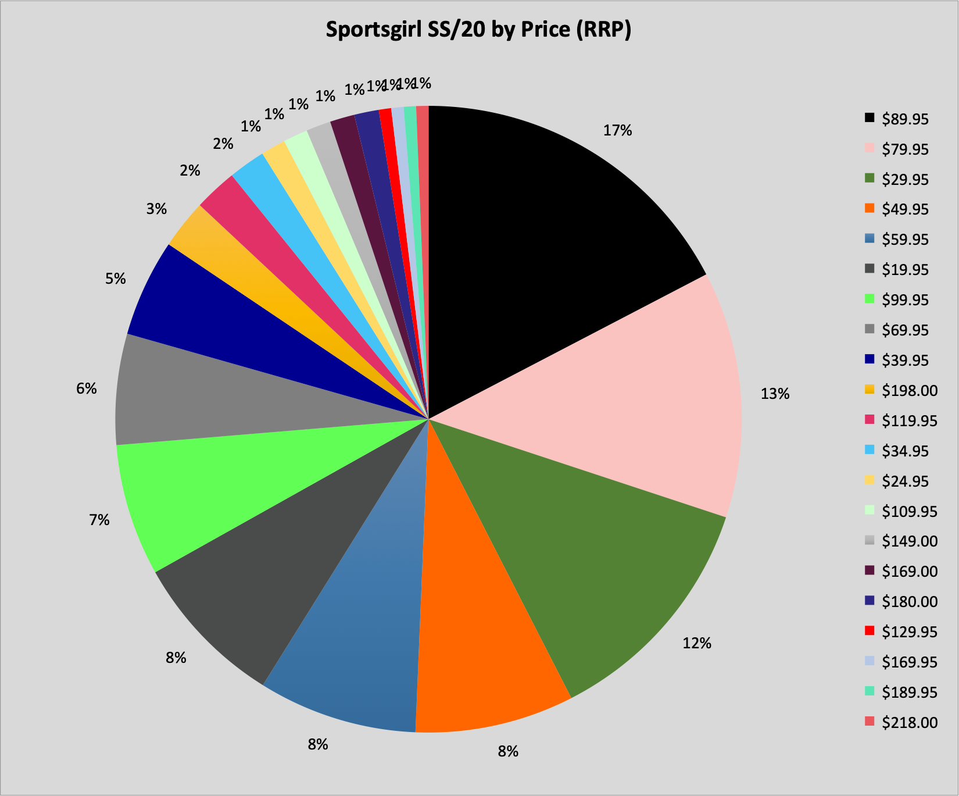

This also reflects on Sportsgirl’s price point strategy and sweet spot which ranged from $59.95 to $99.95 in the last year. Our range price would not be as high due to the lower pricing factor of a tween range and attempting to differentiate pricing would be positive; thus not cannibalizing Sportsgirl sales.

**6. Sweet Spot Errors between Each Month**

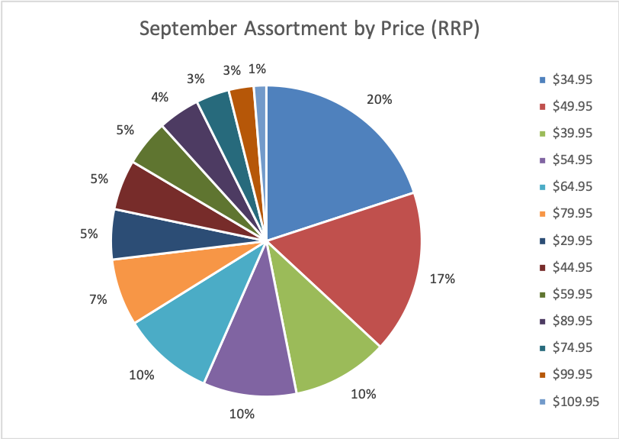

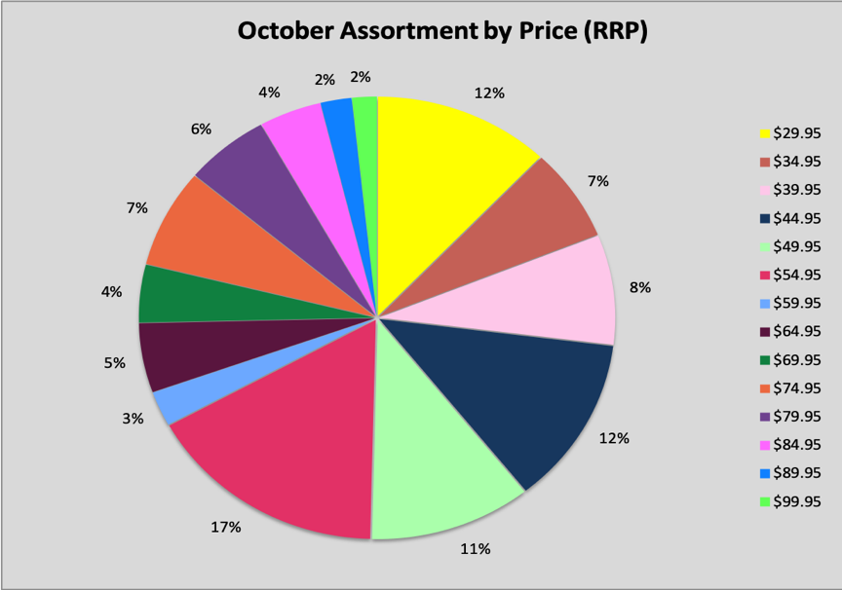

Looking deeper into our range, we dissected our pricing sweet spots between months and found the error where September’s sweet spot was $34.95 as opposed to October which was more expensive at $54.95. These two sweet spots must be the same or even similar, as to not decrease sales with consumers finding one month to be considerably more expensive than the other. Overall, consumer price points should sit similarly between months as well as between competitors and their pricing point strategies.